Ideation Phase
Brainstorm & Idea Prioritization Template

Date | 2 November 2025
Team ID | NM2025TMID07213
Project Name | Laptop Request Catalog Item
Maximum Marks | 4 Marks

Brainstorm & Idea Prioritization Template:
For the 'Laptop Request Catalog Item' project, our Brainstorming and Idea Prioritization efforts will focus on transforming the current manual and delay-prone laptop request process into a quick, efficient, and dynamic ServiceNow Service Catalog experience. We will collaboratively generate a comprehensive range of ideas for variables, dynamic UI policies, approval workflows, and user guidance, prioritizing volume over value initially to capture every possible enhancement for accurate data collection and an intuitive user interface. This will include exploring how to best implement dynamic form behavior, clear instructions, and reset functionality. Subsequently, through a structured prioritization process, we will evaluate these ideas to select the most impactful and feasible solutions for development, ensuring the project delivers a truly user-centric and error-reducing solution that significantly improves employee satisfaction and operational efficiency.

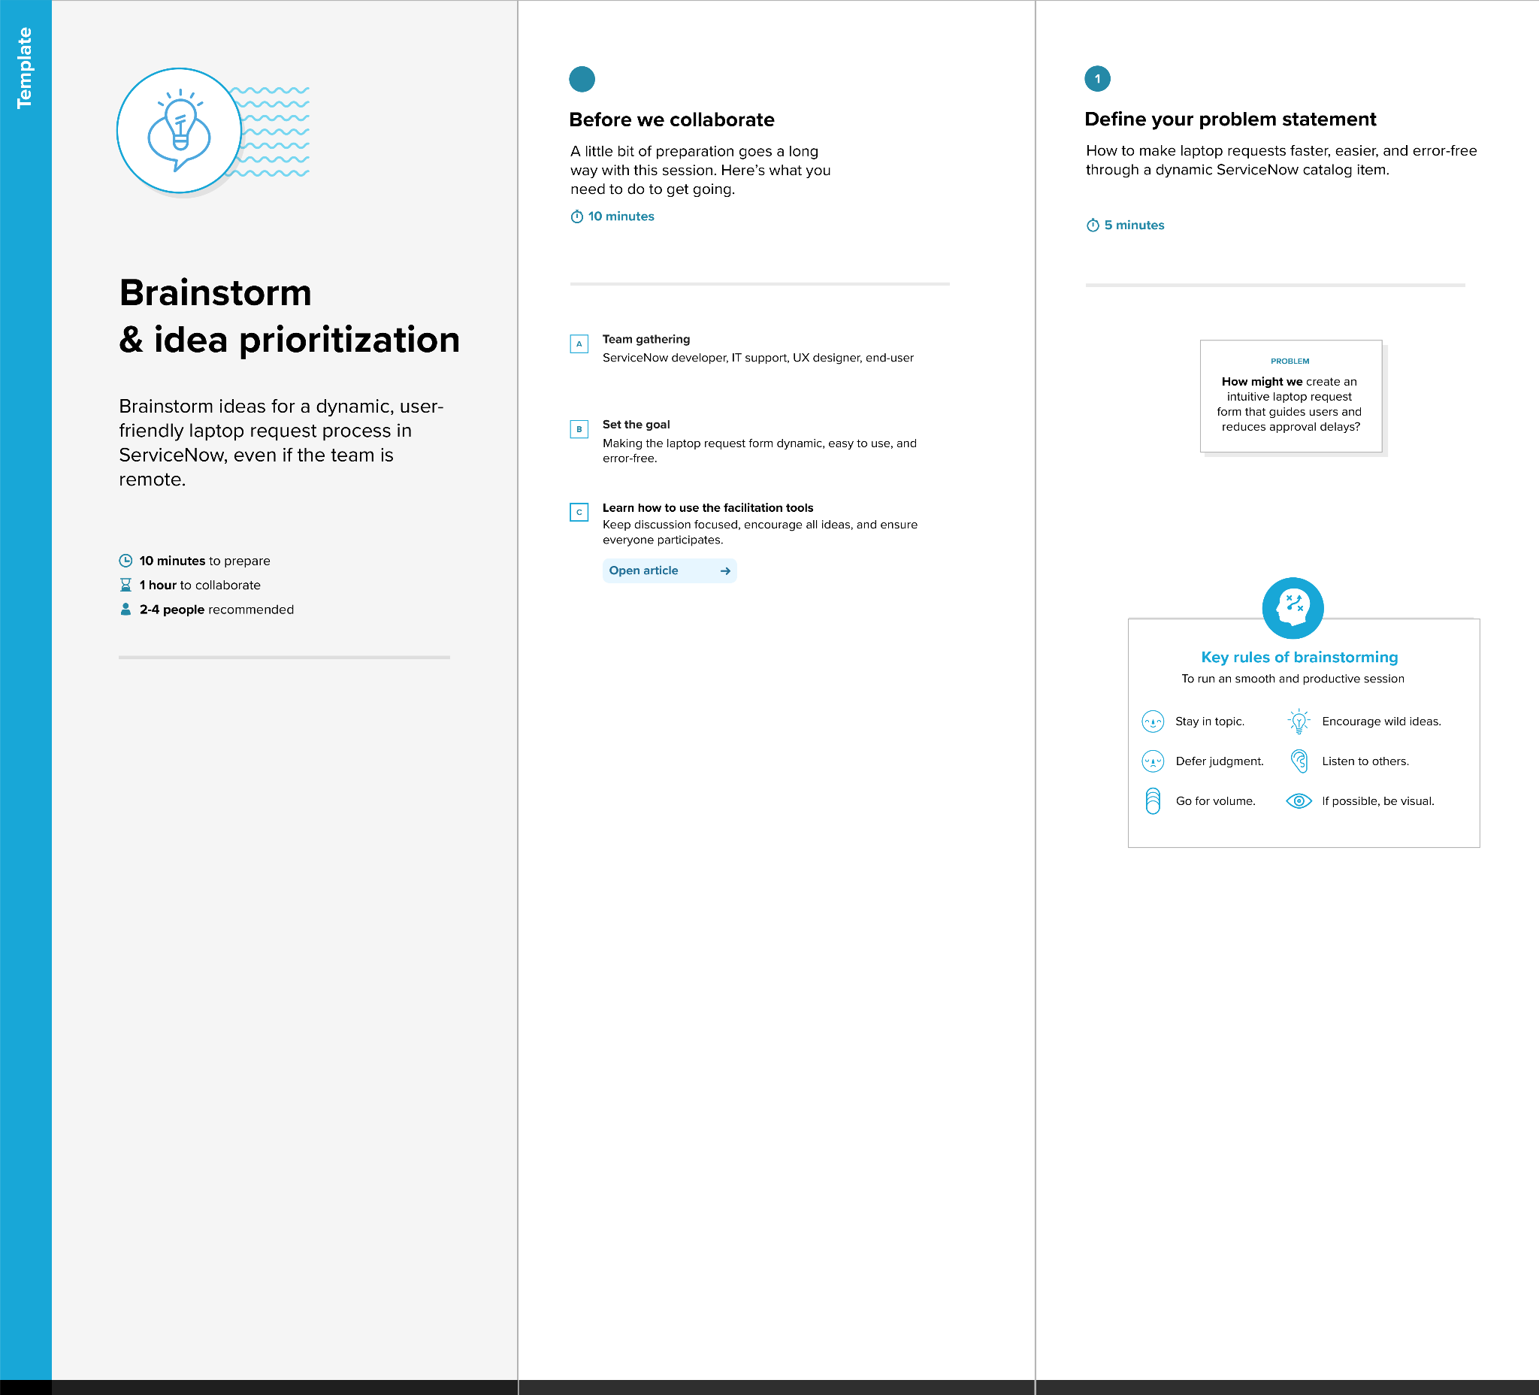
Step-1: Team Gathering, Collaboration and Select the Problem Statement
Step-2: Brainstorm, Idea Listing and Grouping
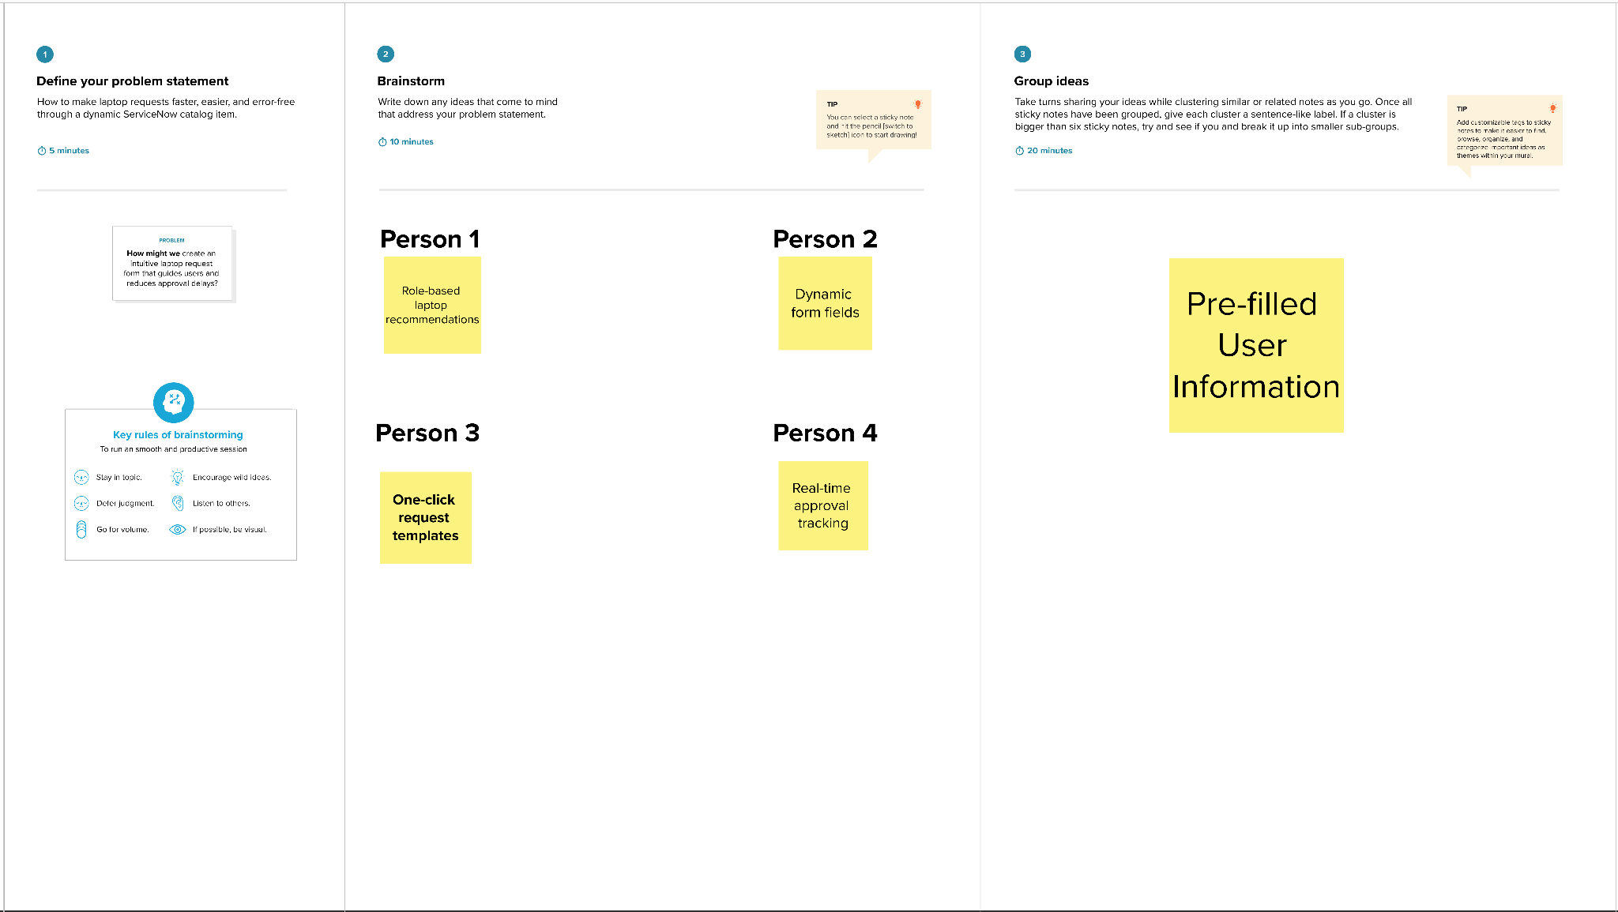

Step-3: Idea Prioritization
